MODEL CURRICULUM FOR ROBOTIC COMPUTER PROGRAMMING
IN THE CLASSROOM
PRESENTED
FEBRUARY 9TH-2016
AT THE OETC PRE-CONFERENCE WORKSHOPS
BY PROFESSOR REED
COLUMBUS, OHIO
COLUMBUS CONVENTION CENTER

Items needed before the Workshop begins:
- Configured EV3 Brick Robot with “color sensor”
- and “sonar sensor” (provided at the event for Workshop use only!)
- Paper Line map (supplied at the Workshop)
- ROBOTC “physical robots” and/or “Virtual Worlds” software installed
- on your laptop (temporary licenses will be provided at the Workshop)
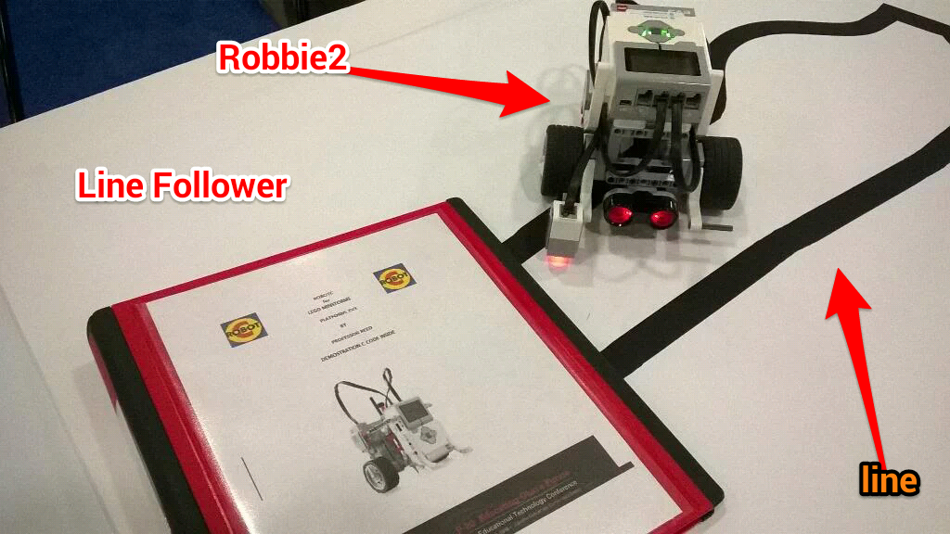
REF: (http://robotc.net/download/lego/)
NO GUI's, NO Graphical Programming Aids, NO Mindstorms
NO pre-canned computer programming routines,
NO LEGO Block or Drag-and-Drop Programming
ROBOT COMPUTER PROGRAMMING PROJECT 1 -- LINE FOLLOWING
- Using ROBOTC (physical or virtual)
develop a computer program to have your Robot follow
an irregular continuous circular line utilizing the EV3's Color Sensor.

- Your EV3 Brick Robot should be able to:
- correctly follow the supplied irregular line drawing
- without assistance--autonmous actions--no assistance or joysticks.
- be picked up an placed back on the field
- and reacquire the line and correctly follow it
- once again--autonmous actions--no assistance or joysticks
- NO GUI's, NO Graphical Programming Aids, NO Block or
- NO pre-canned computer programming routines
- NO LEGO Block or Drag-and-Drop Programming, IE D&D
- Line Follower Challenge No. 1-1:
- Rewrite this same ROBOTC computer program
in Python Computer Language
- Produce the same results as above for Project No. 1

- Line Follower Line Challenge No. 1-2:
- Improve your ROBOTC computer code to
include "line smoothing"
- make your EV3 Robot
smoothly follow the irregular line by
elminating the back--and--forth swing as
the Robot checks for the line edge

ROBOT COMPUTER PROGRAMMING PROJECT 2 -- OBJECT AVOIDANCE
- Using ROBOTC develop a computer program to avoid
an obstructing object placed in its way.
- Your EV3 Brick Robot should be able to:
- detect an obstructing object placed in Robot's path way utilizing
the EV3's Sonar Sensor.
- continue moving forward an appropriate number of wheel turns
forward until encountering an obstucting object in Robot's path
- then stop and back up and try to move forward once again
- repeat object detection process; if needed
you may remove the obstructing object in the path of your robot
- to resume normal forward motion of your Robot
- Object Avoidance Challenge No. 2-1:
- Rewrite this same ROBOTC computer program
for "object avoidance" in Python Computer Language
- Produce the same results as above for Project No. 2

- Object Avoidance Challenge No. 2-2:
- Improve your ROBOTC computer code to
- correctly detect an object blocking its path ahead
- without assistance--autonmous actions--no assistance or joysticks.
- it should go directly into object avoidance mode by
- stopping and then turning 90 degrees Counter Clockwise (CCW)
- moving forward an appropriate number of wheel turns forward
- stopping again and now turning 90 degrees Clockwise (CW)
- moving forward an appropriate number of wheel turns forward
- stopping once again and now turning 90 degrees Clockwise (CW)
- NO GUI's, NO Graphical Programming Aids,
- NO pre-canned computer programming routines,
- NO LEGO Block or Drag-and-Drop Programming, IE D&D

ROBOT COMPUTER PROGRAMMING PROJECT 3 -- "COMBINATION"
LINE FOLLOWING AND OBJECT AVOIDANCE
- Take your successful computer programs written in ROBOTC from
- Projects 1 & 2 above and combined them into a singule integrated
program that allows your Robot to follow the irregular line--from Project 1
- and encounter an object in its path (Project 2) avoid the object
- autonmous actions only--no assistance or joysticks or human assistance
- go around the obstructing object as indicated
- (start avoidance: stop, turn 90d CCW, frwd step(s), stop, turn 90d CW, frwd step(s), stop, turn 90d CW, frwd step(s), stop, turn 90d CCW, end avoidance: begin again going forward using line following)
- reacquire the irregular line
- and continue the line following

Line Follower and Object Avoidance Challenge No. 3-1:
- Rewrite your working ROBOTC combo project in
Python Computer language.

